New Zealand in a rare trade surplus
Falling imports as a result of Covid-19 have given NZ its largest annual trade surplus in six years, with imports continuing to decline. In the 12 months ended August, the trade surplus was NZ$1.3 billion, compared with a deficit of NZ$5.6 billion in the prior year. Goods exports totaled NZ$60.7 billion, up NZ$1.6 billion from the previous year, while annual goods imports were NZ$59.4 billion, down NZ$5.3 billion from the previous year. This also comes as the NZ dollar is on track to experience its biggest weekly fall in almost six months, currently down 3.4%. NZ's current debt is at 31% of GDP, with this expecting to peak at 58% in 2024.

Impact of recent lockdown on spending
New data from the Reserve Bank of NZ has shown that total monthly credit card billings fell 5.8% to NZ$3.6 billion in August, as the Covid-19 alert status was raised to Level 3 in Auckland in the middle of the month and Level 2 for the rest of the country. Billings on domestically issues cards decreased 6% to NZ$3.3 billion and billings on overseas-issued cards decreased 11% to NZ$0.25 billion, due to fewer international visitors in NZ. However, overseas billings on NZ-issued credit cards increased 10% to NZ$0.24 billion, indicating that online shopping continues to increase in popularity.

New Zealand’s businesses still lagging behind OECD when it comes to R&D investments
There has been on-going investment in science and innovation in New Zealand and in recent years R&D investment has increased, however, it is comparatively low among other developed nations. In New Zealand R&D has been slowly increasing from about 0.6% to 0.8% of GDP, yet the OECD average is above 1.5%.
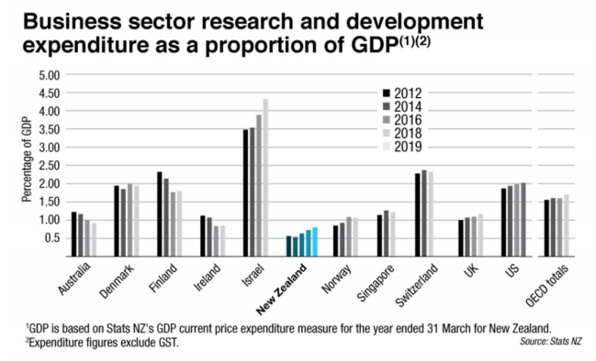

House prices hold strong
Property values have held firm through the worst of the economic downturn, supported by limited supply, record low interest rates and increased market confidence. Overall, values rose 7.6% over the past year, with Auckland's average house price surpassing NZ$1 million in September. Housing stock has also hit a record low which has affected all but one region in NZ. Northland has been the hardest hit, with a 32.8% drop in housing stock over the past 12 months. Nationally, demand still outweighs supply with the total number of homes available for sale in September down 17% on the same month in 2019.

