Unemployment rate rises to 5.3%, underutilisation rate to 13.2%
The unemployment rate in NZ jumped to 5.3% in the three months to September, up from 4% the previous quarter. Stats NZ says there were 37,000 more people unemployed during the quarter, the biggest increase since 1986. The increase of the unemployment rate from 4% to 5.3% indicates that the number of unemployed people grew by about 30% due to COVID. At the same time, the underutilisation rate is also on the rise, meaning that more and more people are working shorter hours than they would be willing to work. Whereas the underutilisation rate was 10.0% in the last quarter of 2019 and 10.4% in the first quarter of 2020, it increased to 13.2% in the third quarter (i.e. 392,000 workers). Wage growth in the 3rd quarter slowed to an annual rate of 1.6%.

Business outlook remains stable in the negative
The below table highlights that business confidence has remained at a -16 points. This negative score means that businesses are less confident in the economic outlook or the Government´s handling of the economy. However, interestingly, the businesses that ANZ have surveyed show that they are increasing their own activity. It is expected that in the following months, without adequate economic stimulus and response from the Government, the summer months would hold large losses due to the lack of international tourists. This can also explain the investment intentions and profit expectations, as New Zealand households look to save for Christmas and the fact that payouts from wage subsidies have ceased.
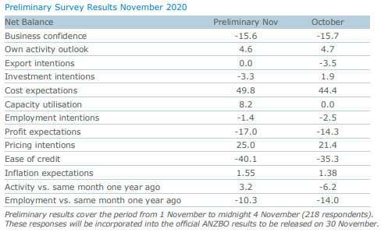
Source: ANZ Research Business Outlook Survey
https://www.anz.co.nz/content/dam/anzconz/documents/economics-and-market-research/2020/ANZ-BusinessOutlook-20201105-Prelim.pdf
The below graphs show the impact COVID and the government change in 2017 has had on business confidence compared to the GFC of 2008. In 2009 the business confidence was around the -40 mark while in 2020 it dropped to below -60, indicating the economic crisis that COVID has created by disrupting supply chain and export markets.
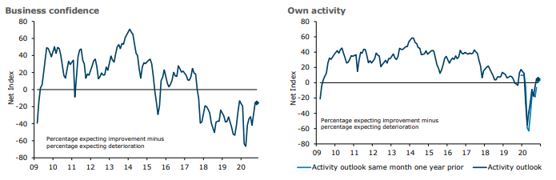
Source: ANZ Research Business Outlook Survey
https://www.anz.co.nz/content/dam/anzconz/documents/economics-and-market-research/2020/ANZ-BusinessOutlook-20201105-Prelim.pdf

Consumer confidence increases
The below graphs show Consumer Confidence has risen by 9 points to 108.7 in October with the outlook that November will rise as well. The key retail spending indicator was that of whether households believed it was a good time to buy a major household item (this improved by 12 points). When Consumer Confidence increases, it means the population is more willing to spend as they believe they are economically stable.

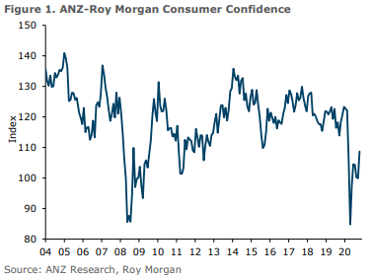
Source: ANZ Research, Roy Morgan
https://www.anz.co.nz/content/dam/anzconz/documents/economics-and-market-research/2020/ANZ-ConsumerConfidence-20201030.pdf

Two-way travel bubble with Australia is closer to reality
New South Wales, Northern Territory, ACT, Victoria and South Australia have all opened their borders to allow NZers to travel without the need to quarantine on arrival. Nevertheless, talking about the trans-Tasman travel bubble in early November, PM Jacinda Ardern warned that there were still coronavirus cases popping up in those places overseas and that it is important to stay cautious. New Zealand is still closed to travellers from Australia. Ardern said she was still waiting for clarification on each Australian state’s COVID-19 border control management systems. She floated the idea of potentially being able to open and close the border to different parts of Australia, depending on hotspots that may break out. New Zealanders have been able to enter certain states of Australia quarantine-free since mid-October, however, they must still quarantine upon return.

New vehicle sales drop sharply in 2020 but electric and hybrid cars still sell well
Based on data from the Motor Industry Association, after the drastic drop in the March–May period, total new passenger car sales (registrations) are edging closer to usual levels in the third quarter, although still 14% below the figures of the July–September period of 2019. Overall, looking at the first ten months period for both 2019 and 2020, there has been over 22% drop in the sales of passenger vehicles. It is worth noting, though, that the drop in sales has been varied in different categories. More prestigious German cars (e.g. Mercedes, BMW, Audi) has seen significantly smaller decrease, under or just around 10%. Despite the drop in total passenger car sales, there is a growing trend in the electric and hybrid vehicles’ market. In 2019 (Jan to Oct) there were a total of 7,197 electric and hybrid vehicles sold, while in 2020 (Jan to Oct) the number increased by 20% to 8,651. As for commercial vehicles, the year-to-year drop in sales in the January to October period was 26%, even bigger than in the passenger car segment, due to the economic downturn and uncertainties caused by COVID-19.

